
Department of Information and Communication Engineering (ICE)
Faculty of Engineering
Semester: Spring, Year: 2025, B.Sc. in ICE
PROJECT REPORT

Course Title: Simulation and Modeling
Course Code: ICE 310
Project Name: Smart Color Detection System Using Arduino Nano
Submitted By | Submitted To
Name & ID:  Faraby Chowdhury (0242310005171026)  Rabea Basry  (0242310005171036)  Level: 3 Term: 1 | Name of Course Teacher:  Tasnia Noshin Orin  Designation: Lecturer  Signature:……………………….

Date of Submission:

Group Members:
Faraby Chowdhury
ID- 0242310005171026
Rabea Basry
ID- 0242310005171036

Title:
Smart Color Detection System Using Arduino Nano

Objective:
To design and implement a real-time color detection system that identifies red, green, and blue colors using an ESP32-CAM and displays the recognized color on an OLED screen. The system is trained using machine learning techniques through Edge Impulse to classify colors based on image input.

Equipment:

Components and Their Functions:
- ESP32-CAM Module:
Captures the image of the color placed in front of the camera. Sends the image to the machine learning model for color detection.

- Arduino Nano:
Acts as a middle controller to receive the detected color result. Controls the OLED display and shows the color name on the screen.

- OLED Display (1.3" SH1106):
Displays the output color name (like RED, GREEN, or BLUE) so that the user can easily see it.

- Breadboard:
Used to make temporary connections between components without soldering.

- Jumper Wires:
Connect different components like ESP32-CAM, Arduino Nano, and OLED display to each other.

- Edge Impulse (Software Tool):
Used to train a machine learning model that can recognize different colors from captured images. The trained model is then deployed on the ESP32-CAM for real-time inference.

Circuit Diagram:
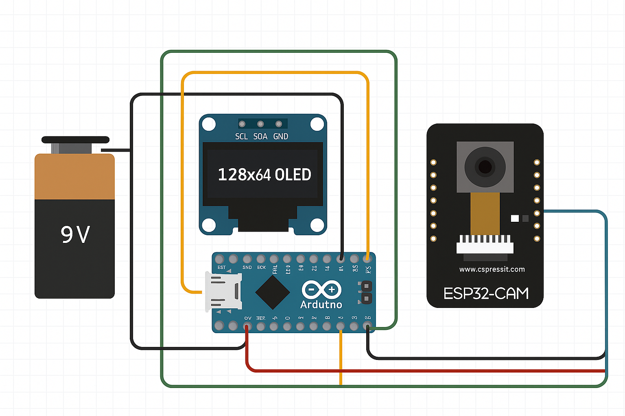

Fig-01: Circuit Diagram

Working Principle:
The Smart Color Recognition System is designed to assist color-blind individuals by identifying and displaying the name of a detected color in real-time. The system operates based on the following steps:

- Image Capture:
The ESP32-CAM module captures an image of the object or surface placed in front of it. This image is used as the input for color detection.

- Model Inference:
The captured image is passed to a trained machine learning model, which was developed and deployed using Edge Impulse. This model is specifically trained to recognize key colors such as red, blue, and green.

- Color Detection and Classification:
The picture is sent to a machine learning model that was trained using Edge Impulse to recognize different colors like pink, red, blue, and green.

- Output Display:
The Arduino Nano receives the color label from the model and displays the detected color name on a 0.96" OLED display, providing a clear visual output.

- Hardware Integration:
All components—ESP32-CAM, Arduino Nano, OLED display, breadboard, and connecting wires—are integrated to work in sync, enabling smooth communication between image capturing, processing, and display.

Applications:
- Smart Sorting Systems:
Can be used in recycling plants or factories to sort items based on color (e.g., separating red, green, and blue objects).
- Agricultural Automation:
Helps in identifying the ripeness of fruits or vegetables based on their color (e.g., green vs. red tomatoes).
- Educational Tools:
Serves as a practical demonstration of machine learning, image processing, and embedded systems for students and hobbyists.
- Color-Based Access Control:
Can be used in games or interactive systems where different colored cards or objects trigger different responses.

- Assistive Technology for the Visually Impaired:
Used to detect and announce colors to help individuals with color blindness or vision impairment.

Code:

#include <Color_Detection_inferencing.h>
#include "esp_camera.h"
#include <Wire.h>
#include <Adafruit_GFX.h>
#include <Adafruit_SH110X.h>

// ==== OLED SETUP (SH1106, 128x64) ====
#define SCREEN_WIDTH 128
#define SCREEN_HEIGHT 64
#define OLED_RESET -1
Adafruit_SH1106G display(SCREEN_WIDTH, SCREEN_HEIGHT, &Wire, OLED_RESET);

// ==== ESP32-CAM Pin Setup ====
#define PWDN_GPIO_NUM 32
#define RESET_GPIO_NUM -1
#define XCLK_GPIO_NUM 0
#define SIOD_GPIO_NUM 26
#define SIOC_GPIO_NUM 27
#define Y9_GPIO_NUM 35
#define Y8_GPIO_NUM 34
#define Y7_GPIO_NUM 39
#define Y6_GPIO_NUM 36
#define Y5_GPIO_NUM 21
#define Y4_GPIO_NUM 19
#define Y3_GPIO_NUM 18
#define Y2_GPIO_NUM 5
#define VSYNC_GPIO_NUM 25
#define HREF_GPIO_NUM 23
#define PCLK_GPIO_NUM 22

static bool is_initialized = false;
uint8_t *snapshot_buf;

// Camera configuration
camera_config_t camera_config = {
.pin_pwdn = PWDN_GPIO_NUM,
.pin_reset = RESET_GPIO_NUM,
.pin_xclk = XCLK_GPIO_NUM,
.pin_sscb_sda = SIOD_GPIO_NUM,
.pin_sscb_scl = SIOC_GPIO_NUM,
.pin_d7 = Y9_GPIO_NUM,
.pin_d6 = Y8_GPIO_NUM,
.pin_d5 = Y7_GPIO_NUM,
.pin_d4 = Y6_GPIO_NUM,
.pin_d3 = Y5_GPIO_NUM,
.pin_d2 = Y4_GPIO_NUM,
.pin_d1 = Y3_GPIO_NUM,
.pin_d0 = Y2_GPIO_NUM,
.pin_vsync = VSYNC_GPIO_NUM,
.pin_href = HREF_GPIO_NUM,
.pin_pclk = PCLK_GPIO_NUM,
.xclk_freq_hz = 20000000,
.pixel_format = PIXFORMAT_JPEG,
.frame_size = FRAMESIZE_QVGA,
.jpeg_quality = 12,
.fb_count = 1
};

// ===== OLED UPDATE FUNCTION =====
void updateDisplay(const char* label) {
display.clearDisplay();
display.setTextSize(2);
display.setTextColor(SH110X_WHITE);
display.setCursor(0, 0);
display.println("Detected:");
display.setTextSize(3);
display.setCursor(0, 30);
display.println(label);
display.display();
}

// ===== CAMERA INIT =====
bool initCamera() {
if (is_initialized) return true;
esp_err_t err = esp_camera_init(&camera_config);
if (err != ESP_OK) {
Serial.printf("Camera init failed: 0x%x\n", err);
return false;
}
is_initialized = true;
return true;
}

// ===== GET CAMERA FRAME & CONVERT =====
bool captureFrame(uint8_t *buffer) {
if (!is_initialized) return false;
camera_fb_t *fb = esp_camera_fb_get();
if (!fb) {
Serial.println("Camera capture failed");
return false;
}

bool success = fmt2rgb888(fb->buf, fb->len, PIXFORMAT_JPEG, buffer);
esp_camera_fb_return(fb);

if (!success) {
Serial.println("RGB conversion failed");
return false;
}
return true;
}

// ===== EDGE IMPULSE SIGNAL CALLBACK =====
static int get_image_data(size_t offset, size_t length, float *out_ptr) {
size_t pixel_ix = offset * 3;
size_t out_ix = 0;

while (length--) {
uint8_t r = snapshot_buf[pixel_ix];
uint8_t g = snapshot_buf[pixel_ix + 1];
uint8_t b = snapshot_buf[pixel_ix + 2];
out_ptr[out_ix++] = (r << 16) + (g << 8) + b;
pixel_ix += 3;
}
return 0;
}

// ===== ARDUINO SETUP =====
void setup() {
Serial.begin(115200);

// Disable flash LED
pinMode(4, OUTPUT);
digitalWrite(4, LOW);

// OLED INIT (SDA = GPIO2, SCL = GPIO15)
Wire.begin(2, 15);
if (!display.begin(0x3C, true)) {
Serial.println("OLED init failed");
while (1);
}
display.clearDisplay();
display.setTextSize(2);
display.setCursor(0, 0);
display.println("Booting...");
display.display();

// Camera init
if (!initCamera()) {
display.println("Camera Fail");
display.display();
while (1);
}

display.clearDisplay();
display.setCursor(0, 0);
display.println("System Ready");
display.display();
delay(2000);
}

// ===== ARDUINO LOOP =====
void loop() {
snapshot_buf = (uint8_t *)malloc(EI_CLASSIFIER_INPUT_WIDTH * EI_CLASSIFIER_INPUT_HEIGHT * 3);
if (!snapshot_buf) {
Serial.println("Buffer malloc failed");
return;
}

if (!captureFrame(snapshot_buf)) {
free(snapshot_buf);
return;
}

// Setup signal
ei::signal_t signal;
signal.total_length = EI_CLASSIFIER_INPUT_WIDTH * EI_CLASSIFIER_INPUT_HEIGHT;
signal.get_data = &get_image_data;

// Run classifier
ei_impulse_result_t result = { 0 };
EI_IMPULSE_ERROR err = run_classifier(&signal, &result, false);

if (err != EI_IMPULSE_OK) {
Serial.printf("Inference failed: %d\n", err);
free(snapshot_buf);
return;
}

// Get top label (no confidence logic)
const char* detected_label = "NONE";

for (size_t ix = 0; ix < EI_CLASSIFIER_LABEL_COUNT; ix++) {
const char* label = ei_classifier_inferencing_categories[ix];
if (strcmp(label, "RED") == 0 || strcmp(label, "GREEN") == 0 || strcmp(label, "BLUE") == 0) {
detected_label = label;
break; // Show the first detected label
}
}

updateDisplay(detected_label);
free(snapshot_buf);
delay(500); // Avoid flickering
}

#if !defined(EI_CLASSIFIER_SENSOR) || (EI_CLASSIFIER_SENSOR != EI_CLASSIFIER_SENSOR_CAMERA)
#error "Invalid model: selected model is not camera-compatible."
#endif

Discussion:
In this project, our main goal was to help color blind individuals by using a smart color recognition system. At first, we planned to include five colors in the detection model: red, green, blue, pink, and yellow. We trained the model using Edge Impulse, and tested it many times. However, we faced a major challenge with pink and yellow colors. The ESP32-CAM's camera resolution was not good enough to clearly capture these colors. As a result, the model could not detect pink and yellow correctly, even after training the model more than five times with different image sets. After many trials and errors, we decided to remove pink and yellow from the model and focused only on red, green, and blue. After this change, the model performed much better, and the ESP32-CAM was able to detect the colors correctly. After completing the color detection part, we moved on to the OLED display integration using Arduino Nano. This part was also difficult, as the OLED did not work properly in the beginning. We tried many codes, changed libraries, checked wiring, and spent a lot of time debugging. Finally, we were able to make the OLED display show the detected color names successfully. Unfortunately, during the final showcasing of the project in front of teachers, the system did not work properly. This might have been due to loose connections, unstable power supply, or delays in camera processing. Even though it worked during testing, it failed during the live demonstration, which was disappointing. Despite these challenges, we have learned a lot about hardware troubleshooting, machine learning model training, and real-time system integration. If we get more time and better hardware (like a higher quality camera), we believe the project can be improved further.

